Name : Ilham Idkha Syaifudin
NIM : L200164010
Class X
Assignment 1
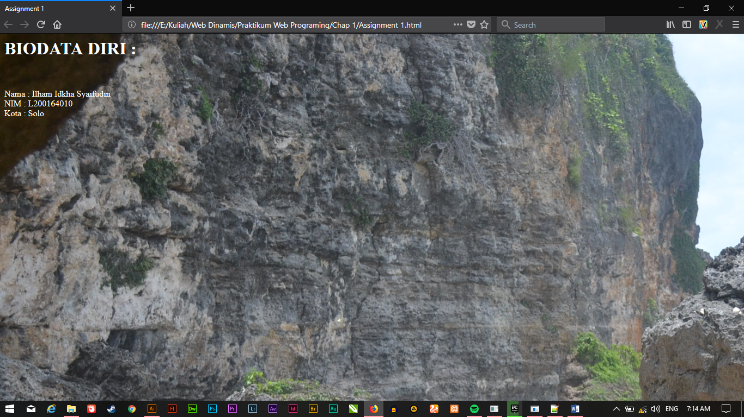
Code :
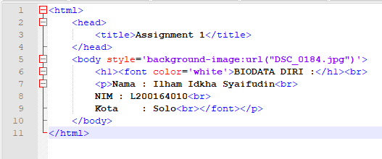
Assignment 2
No | Tag/Atribute | Function
1 | Bgcolor=”Blue” | Creating background color is Blue
2 | <h1> - <h6> | Creating header one(bigger) to header six(smaller)
3 | <font> … </font> | Setting the kind (size, color and etc.) of font in one sentence or article
4 | Face=’verdana’ | Setting the font to Verdana style
5 | Size = ‘10’ | Change the size of font to 10
6 | Color=’blue’ | To setting color to blue
7 | <b> … </b> | Creating bold font
8 | <i> … </i> | Creating italic font
9 | <u> … </u> | Creating Underline font
10 | <strike> … <strike> | Creating middleline font
11 | <sup> … <sup> | Creating superscripted
12 | <sub> … <sub> | Creating subscripted
13 | <p> … </p> | Creating a new paragraph
14 | Align=’centar’ | Change position to the center of document
15 | <img> | To insert image
16 | Src=’gambar.jpg’ | As a source of image
17 | Width=’100’ | To setting the width in 100 pixel
18 | Height=’100’ | To setting the height in 100 pixel
19 | Alt=’alt’
20 | <ul> … </ul> | Unorder list
21 | <ol> … </ol> | Order list
22 | <li> … </li> | To creat list
23 | Type=’circle’ | To setting type mark of list
24 | <table> … </table> | Creating the table
25 | <tr> … <tr> | Creating rows table
26 | <td> … </td> | Creating data table
27 | Border=’2px’ | Creating border table to 2 pixel
28 | Colspan=’2’ | Span the table into 2 coloumn table
29 | Rowspan=’2’ | Span the table into 2 rows table
30 | </br> | Break line to change paragraph

